**Assignment 3**

**Creation of Volume and attaching it to an instance:**

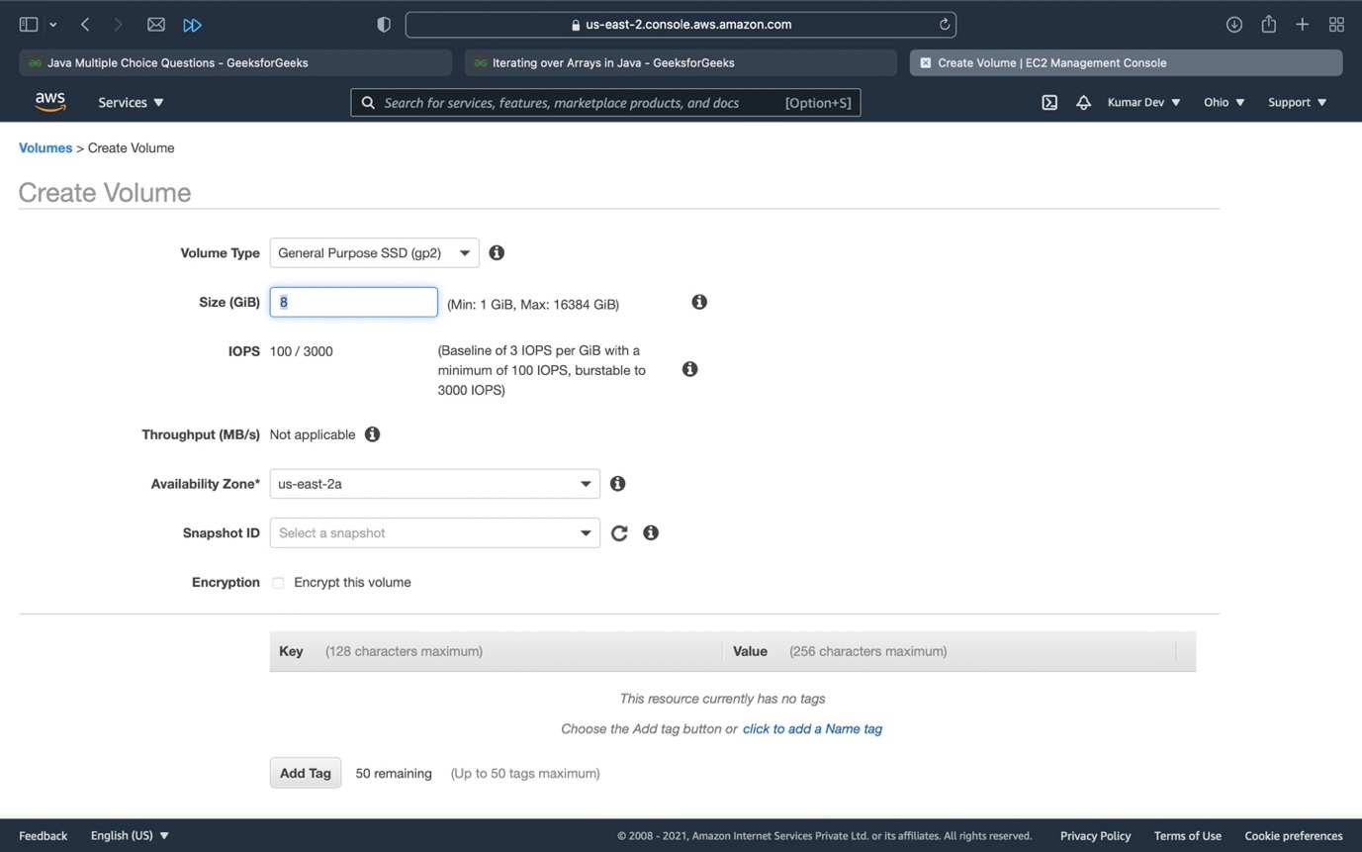

Here we have to select an availability zone and select size of the volume, then click on create volume.

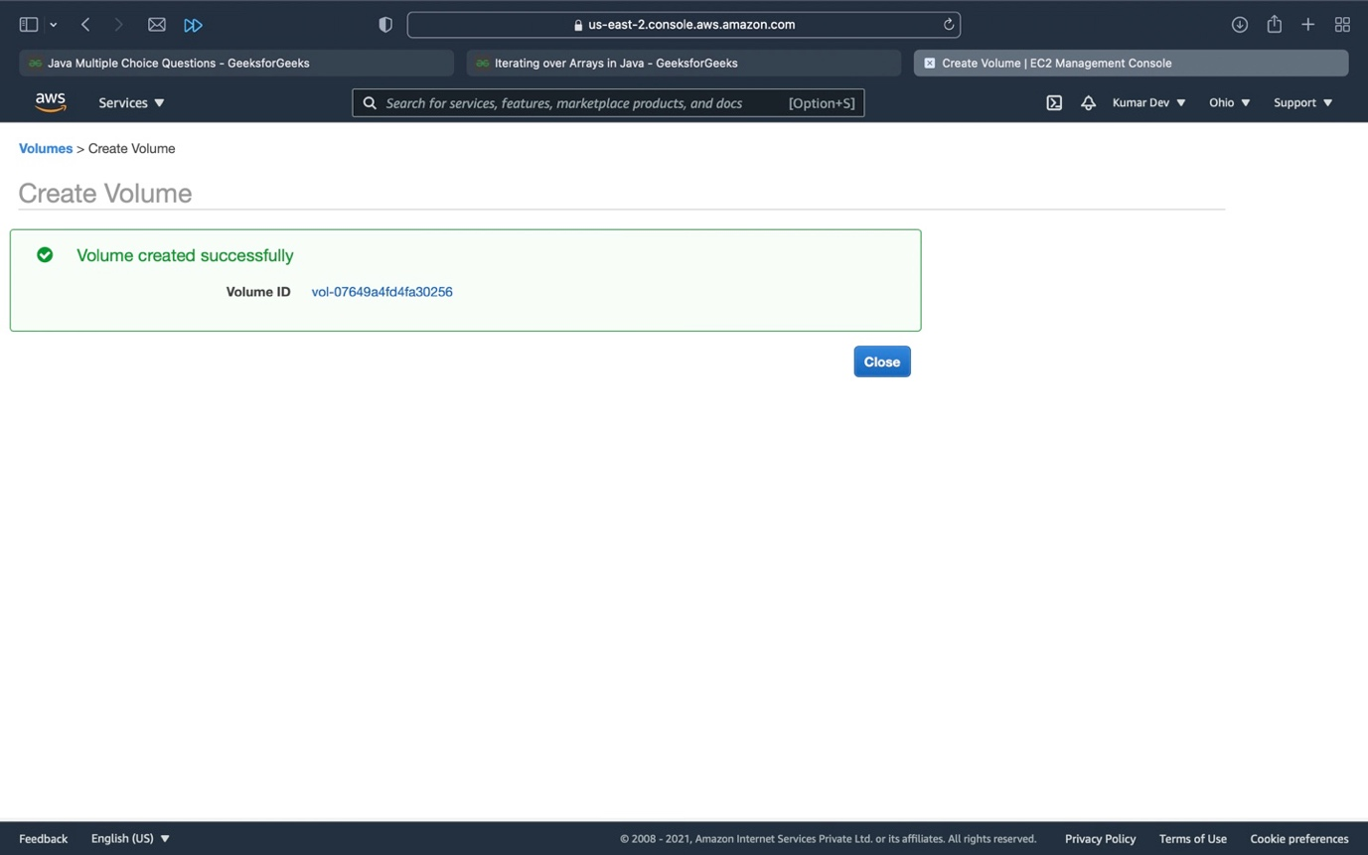

Here volume is created.

To attach a volume with instance.

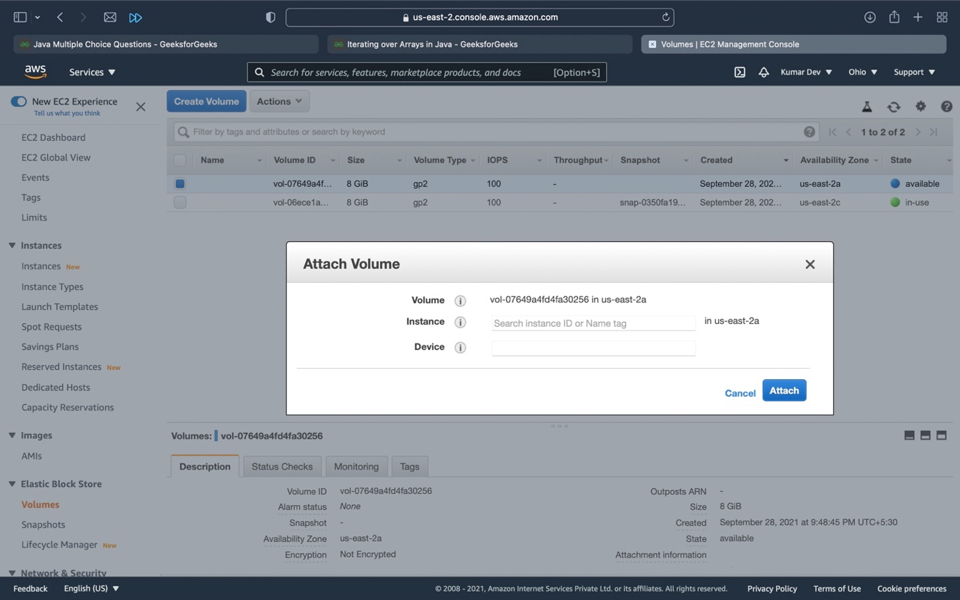

Here we have to give the name of the instance and device name then click on attach to attach.

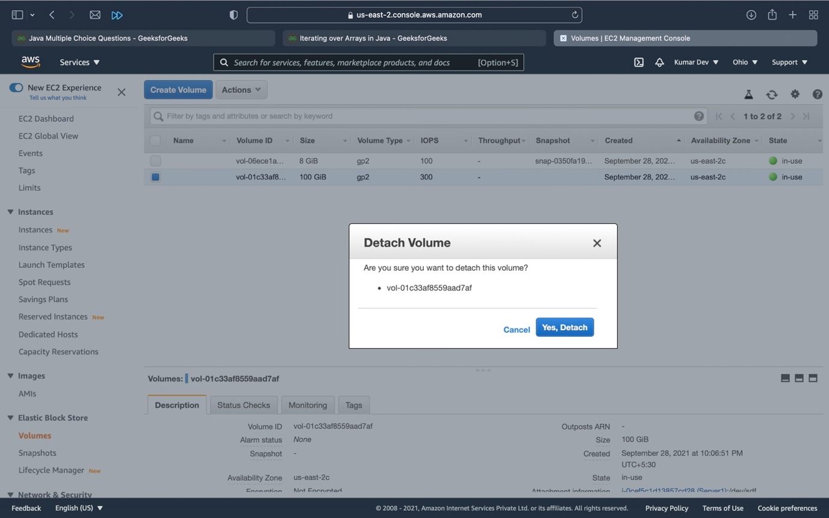

Here click on Detach-to-detach volume.

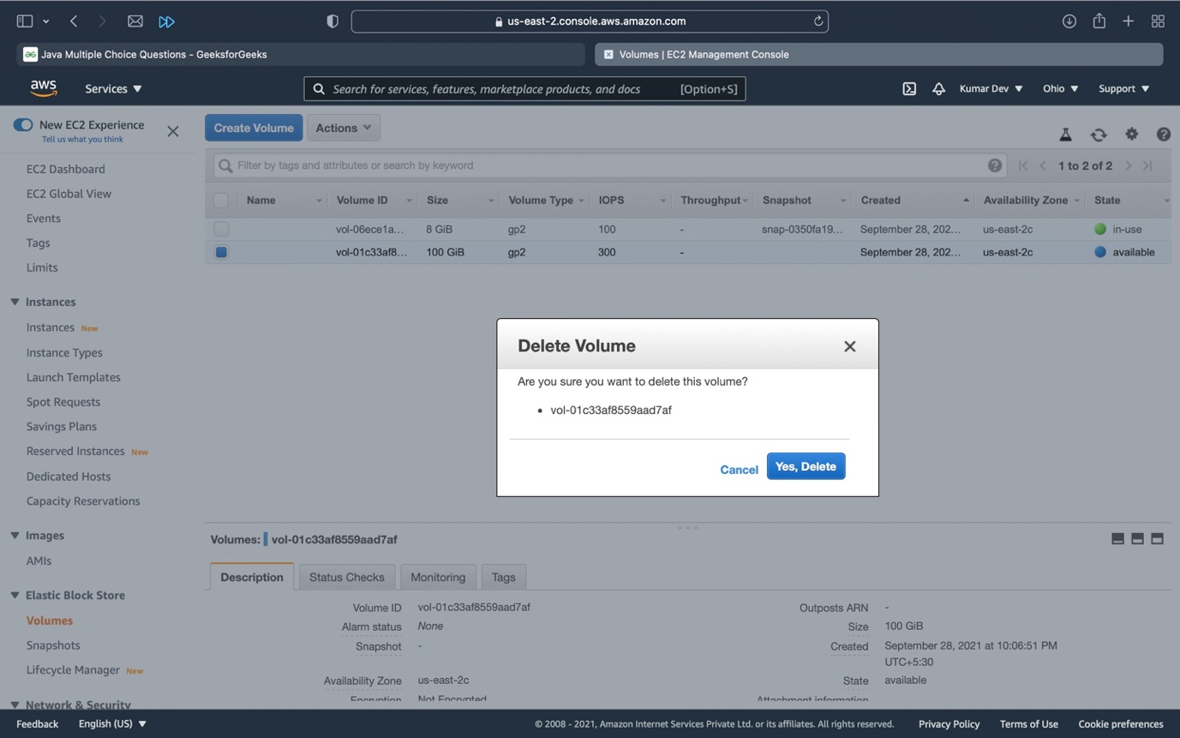

Here we have to click on delete to delete volume.